Please pray for our Dead whose Anniversaries occur about this time:
Johanna Walsh, Gerald Jones, William Miller, Betty Martin, Joan Mather, Grace How, Moira Chester, Patricia Ling, Elizabeth Jones, Patrick Curley, Angelo Papa, Dorothy Bishop, Frederick Todd,
Dorothy O’Reilly, Emily Murray, James Marrey, Peter Lashmar, John Charlton and Walter Heraty.

Please pray for all who are sick in our hospital, our nursing homes and at home. For those who are anxious, bereaved or struggling in the Faith. May they experience the healing hands of Jesus through our prayerful actions and visitations. Especially we pray for:
John Abbott, Margaret Alake, Bob Cole, Dyllis Dangerfield,
Jose De Abreu, Fr John Duckett, Joanne Fitzsimmons, Veronica Flood, Marie Gahagan,
Margaret Harvey, Eileen Heneghan, Ben Holmes, Evelyn Hughes,
Fatima Hussein, Hannah Jermain, Benjamin Joseph, Paula Lam, Mrs D Langan,
Ann Montgomery, Teishan Mulholland, Fr Martin Nott, Brendan O’Connor,
Chioma Onwumere, Bernadette O’Sullivan, Fr Eamonn Power,
Fr John Taylor, Andrew Todd, Danny Toye, Eileen Terrell, Martine Vella,
Betty Walsh and Trudy Wijeyeratnam

Parish Stewardship: Offertory Collection Weekend: 9th /10th June
Envelopes: £381.60 Cash: £431.68 Standing Orders to 5th May £1,717.52

Stewards of the Gospel: The future of our parish
Following the open parish meeting last February, attended by over sixty parishioners, we have been working behind the scenes to take the next steps in response to the points raised that day, including those in the previous questionnaires. The next steps in our journey, including laying the foundations for closer collaboration with neighbouring parishes as proposed in the Diocesan document, ‘Working Together to Evangelise Our Diocese,’ will involve a more formalised structure representing the main strands of our parish organisations. To hear more about what is being proposed, all parishioners are invited to a meeting, at which Fr. Tom will also be present, in the Community Centre on
THIS WEDNESDAY 20TH JUNE at 7.00pm

St Peter’s School 50th Birthday Celebrations
In the New Year we celebrated 50 years of our school being sited here in Dorset Avenue and are extremely excited to be thinking of planning a range of events to mark this important milestone in our history. We would like to invite members of the parish to our Feast Day Mass on Friday 29th June at 10am which will mark the beginning of our celebrations. Parking will be available after 9.45am and Light Refreshments will be served after Mass

St Peter's School Summer Fayre
takes place on 30th June 11am-3pm and it would be great to see you there, helping to support our school. If you wish to donate any goods for the Summer Fayre they will be gratefully received, especially any plants we could sell on the day. Please contact Claire Clist on 07921 511 442 or by email at stpeterssft@gmail.com for more information. Thank you for your support.
Grand Draw Tickets will be available after all Masses this weekend.
Charities Committee invitation to Strawberry Teas
Next Sunday 24th June: 3pm- 5pm in the Parish Hall
Proceeds will be divided between Huntington’s Disease Research & The Homeless.
Please come along and support these worthy causes while enjoying a strawberry tea with family and friends.
Parish Building and Maintenance Fund Next weekend after all Masses we will have the monthly collection for the Parish Building and Maintenance Fund.
Ascot Bingo Come and join us in the Community Centre on Thursday 21st June, 7.30pm for 8pm for a fun Ascot Evening. Hats would be lovely!
Long Service Celebration Event On behalf of St. Peter’s school, Mrs Waterfield would like to invite past pupils and parents to join them to celebrate and give thanks for the tremendous service given to the school by two of our staff. Mrs Maria O’Bryan has worked at the school for over 16 years as class teacher and SENCO, and Mr Nigel Hooton, Class Teacher and IT lead who has been with us for 10 years. We are holding a SURPRISE BBQ on Wednesday 18th July at 7pm at the school. Guests are asked to arrive at 6.30pm. RSVP the school office 01708 745506 for catering purposes. Contributions towards gifts will be welcomed-please mark for the attention of Barbara Waring, school office manager
Marriage and Family Life There will be a Mass of Thanksgiving with the Bishop at Brentwood Cathedral on Saturday 14th July at 4pm. It would be good to be able to send four couples and children from our parish. Please see Fr Tom for an ‘invitation card’.
The Gospel of Mark On Wednesdays 20th and 27th June at 7 pm Fr Adrian Graffy will lead an exploration of the Gospel of Mark. These ‘Gidea Park Faith Evenings’ will take place in the hall at Gidea Park Catholic Church (410 Brentwood Road, Gidea Park, RM2 6DH). Please book by email to GPstudydays@gmail.com Refreshments provided. Admission free.
St John Bosco Children’s Camp Information and dates for Summer Camp 2018 can be found at the back of the church or visit www.svpboscocamp.org.uk
Caritas (Social Justice and Charity) I invite anyone in our parish to gather for a conversation about Social Justice on Saturday 7th July at Brentwood Ursuline High School, from 10.30am - 3.30pm. If you are interested, please pick up a copy letter from the Vicariate for Pastoral Formation from the back of the church to find out more.
Samsung Phone Found in the Parish Car park. Please contact the parish office.
English Martyrs Hornchurch - Pilgrimage to the Holy Land 2019 pilgrimage to the Holy Land led by Fr Britto. Thurs 7th - Thurs 14th March 2019. Please contact the parish office at English Martyrs: 01708 507020 / hornchurchem@dioceseofbrentwood.org for details.
Home from Home for the Elderly are seeking new volunteers (both admin and practical) and also new trustees. Our charity currently provides much needed befriending services to the elderly and a monthly social group. We are not looking for huge time commitments, many hands make light work! For more information, or to arrange to meet with us, please contact our trustees via Joanne Challis on 01708 747026 or e-mail: admin@hfh4elderly.org

This Week in Church

Saturday 16th 6.30pm Nellie Stack RIP (Kelly)
Sunday 17th 9.30am Joseph O’Shea RIP (Darcy)
11.30am The People of the Parish
Monday 18th 12noon Sonny Condon RIP (McCurtains)
Tuesday 19th 12noon Holy Souls (Herbert)
Wednesday 20th 12.15pm Ettie Kelly RIP (Yvonne & Kieran)
Thursday 21st 8.30am Service of the Word/Holy Communion
Friday 22nd 12noon Dorothy Bishop (Foundation)
Saturday 23rd 6.30pm Mary & Jim Holland (Holland/Wiseman)
Sunday 24th 9.30am The People of the Parish
11.30am Chris Kenneally RIP (Harrington)
Morning Prayer of the Church is celebrated after the morning services. Exposition of the Blessed Sacrament normally takes place on Saturday morning’s during the Sacrament of Reconciliation from 11am - 12noon.
The Sacrament of Reconciliation is normally held on Saturday between 11am - 12.00 noon & 5.30pm. – 6.15pm.

What’s On?

Mon 18th St Edwards Preschool 9.15am-3.00pm Parish Hall
Stewards of the Gospel 12.30pm Priest’s House
Knit & Natter 2.30pm-4.30pm Community Centre
Pastoral Meetings 5pm & 6pm Priest’s House
Tues 19th Parent & Toddler Group 9.45am-11.45am Parish Hall
Spiritual Direction 11.00am Priest’s House
Hospital 2.30pm London
Beavers/Cubs/Scouts 5.00pm-9.30pm Parish Hall
St Vincent de Paul 7.00pm Community Centre
Weds 20th St Edwards Preschool 9.15am-3.00pm Parish Hall
Golden Club 1.00pm Community Centre
Stewards of the Gospel 7.00pm Community Centre
Guides 7pm-8.30pm Parish Hall
Thurs 21st St Edwards Preschool 9.30am-12.30pm Parish Hall
Hospital 2.00pm London
Fri 22nd St Edwards Preschool 9.15am-3.00pm Parish Hall
Sat 23rd Marriage Instruction 1.00pm Priest’s House
Sun 24th Legion of Mary after 11.30am Mass Upper Room
Baptisms 1.00pm Church
Strawberry Tea 3pm-5pm Parish Hall

Travelling Chalice Collectors Rota
Please return the Chalice BEFORE
the next person is scheduled to collect it
6.30pm 9.30am 11.30am
16th /17th Carmel Osefoh Michael & Anne John Omokore & David Andy & Christian
23rd /24th June Tom & Ian John Sizer & John Shean Maureen & Tony
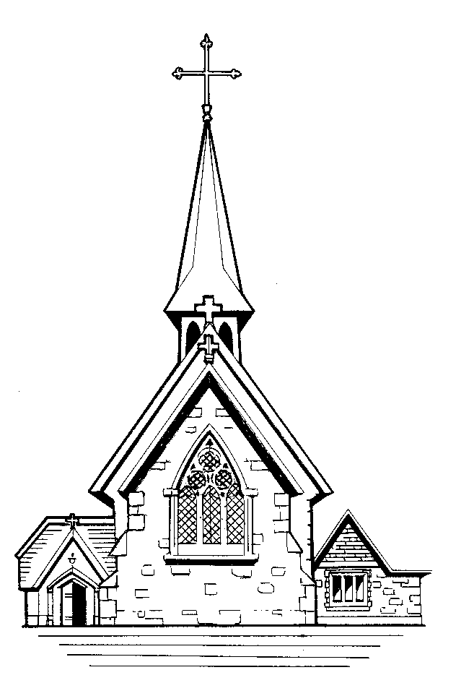 | Parish newsletter ST. EDWARD THE CONFESSOR  CATHOLIC CHURCH  (St Edward is the Patron Saint of our Deanery)  Parish Priest: Father Tom Jordan  5 Park End Road, Romford, Essex RM1 4AT  Telephone & Fax: 01708 740308  e-mail: romford@dioceseofbrentwood.org  Parish Website www.stedwards-romford.org.uk  Diocese of Brentwood Registered Charity No.234092  Web Site: www.dioceseofbrentwood.net  -----------------------------------------------------------------------  St. Peter’s Primary School 01708 745506  Head Teacher: Mrs Jenny Waterfield

Our Parish is part of the Brentwood Diocese and Alan Williams is our Bishop
and we belong to the Havering Deanery.
We are twinned with the parish of Regina Pacis, Ladysmith, Diocese of Dundee, South Africa,
and pray for their Bishop, Graham Rose

Eleventh Sunday of the Year (B)

17th June 2018

The evangelist Mark gathers together several of the parables of Jesus in what becomes chapter 4 of his gospel. Three of these parables speak of the growth of a seed. The parable of the sower, which comes at the start of the chapter, considered different responses to the preaching of the word of God. The parables before us now are concerned with other aspects of growth. The first of our parables, known as the parable of ‘the seed growing secretly’ is unique to Mark, found in no other gospel. Its meaning is clear. Jesus is saying that the work of the kingdom of God is mysterious and profound. We do not understand how God works in the world, and within the human heart. But the work of God will achieve its purpose. The harvest will come, provided we do not thwart it. Our second parable, the parable of the mustard seed, shows another dimension. The mustard seed is tiny, but the growth of the kingdom is great. The kingdom, like the mustard shrub, provides shelter and shade. The kingdom of God provides support and sustenance. Mark ends this section of parables by speaking of Jesus’ purpose in using parables. His intention was not to confuse but to explain the work of God in the world and in the human heart. Those who are open to understanding will gradually come to know more. The work of the grace of Christ is slow but deep.

