Please pray for our Dead whose Anniversaries occur about this time:
Maureen Piper, Joseph Barlow, Peter Schroeyers, Vesta Grimsey, Patricia Sutton, Arthur Coligan, Margaret Moriarty, William Doherty, William Fagan, David Adams,
Olga Mitchell and Elizabeth Fogarty.

Please pray for all who are sick in our hospital, our nursing homes and at home. For those who are anxious, bereaved or struggling in the Faith. May they experience the healing hands of Jesus through our prayerful actions and visitations. Especially we pray for:
John Abbott, Margaret Alake, Bob Cole, Dyllis Dangerfield,
Jose De Abreu, Fr John Duckett, Joanne Fitzsimmons, Veronica Flood, Marie Gahagan,
Margaret Harvey, Eileen Heneghan, Ben Holmes, Evelyn Hughes,
Fatima Hussein, Hannah Jermain, Benjamin Joseph, Paula Lam, Mrs D Langan,
Ann Montgomery, Teishan Mulholland, Fr Martin Nott, Brendan O’Connor,
Chioma Onwumere, Bernadette O’Sullivan, Fr Eamonn Power,
Fr John Taylor, Andrew Todd, Danny Toye, Eileen Terrell, Martine Vella,
Betty Walsh and Trudy Wijeyeratnam

Parish Stewardship: Offertory Collection Weekend: 2nd /3rd June
Envelopes: £444.20 Cash: £356.28 Standing Orders to 5th May £1,717.52

Stewards of the Gospel: The future of our parish
Following the open parish meeting last February, attended by over sixty parishioners, we have been working behind the scenes to take the next steps in response to the points raised that day, including those in the previous questionnaires. The next steps in our journey, including laying the foundations for closer collaboration with neighbouring parishes as proposed in the Diocesan document, ‘Working Together to Evangelise Our Diocese,’ will involve a more formalised structure representing the main strands of our parish organisations. To hear more about what is being proposed, all parishioners are invited to a meeting, at which Fr. Tom will also be present, in the Community Centre on
Wednesday 20th June at 7.00pm

St Peter’s School 50th Birthday Celebrations
In the New Year we celebrated 50 years of our school being sited here in Dorset Avenue and are extremely excited to be thinking of planning a range of events to mark this important milestone in our history. We would like to invite members of the parish to our Feast Day Mass on Friday 29th June at 10am which will mark the beginning of our celebrations. Parking will be available after 9.45am and Light Refreshments will be served after Mass

St Peter's School Summer Fayre
takes place on 30th June 11am-3pm and it would be great to see you there, helping to support our school. If you wish to donate any goods for the Summer Fayre they will be gratefully received, especially any plants we could sell on the day. Please contact Claire Clist on 07921 511 442 or by email at stpeterssft@gmail.com for more information. Thank you for your support.

Charities Committee invitation to Strawberry Teas
Sunday 24th June: 3pm- 5pm in the Parish Hall
Proceeds will be divided between Huntington’s Disease Research & The Homeless.
Please come along and support these worthy causes while enjoying a strawberry tea with family and friends.

Sick & Retired Clergy Fund The retiring collection raised £559.38. Bless you for your generosity.
Long Service Celebration Event On behalf of St. Peter’s school, Mrs Waterfield would like to invite past pupils and parents to join them to celebrate and give thanks for the tremendous service given to the school by two of our staff. Mrs Maria O’Bryan has worked at the school for over 16 years as class teacher and SENCO, and Mr Nigel Hooton, Class Teacher and IT lead who has been with us for 10 years. We are holding a SURPRISE BBQ on Wednesday 18th July at 7pm at the school. Guests are asked to arrive at 6.30pm. RSVP the school office 01708 745506 for catering purposes. Contributions towards gifts will be welcomed-please mark for the attention of Barbara Waring, school office manager
Marriage and Family Life There will be a Mass of Thanksgiving with the Bishop at Brentwood Cathedral on Saturday 14th July at 4pm. It would be good to be able to send four couples and children from our parish. Please see Fr Tom for an ‘invitation card’.
The Gospel of Mark On Wednesdays 20th and 27th June at 7 pm Fr Adrian Graffy will lead an exploration of the Gospel of Mark. These ‘Gidea Park Faith Evenings’ will take place in the hall at Gidea Park Catholic Church (410 Brentwood Road, Gidea Park, RM2 6DH). Please book by email to GPstudydays@gmail.com Refreshments provided. Admission free.
St John Bosco Children’s Camp Information and dates for Summer Camp 2018 can be found at the back of the church or visit www.svpboscocamp.org.uk
Caritas (Social Justice and Charity) I invite anyone in our parish to gather for a conversation about Social Justice on Saturday 7th July at Brentwood Ursuline High School, from 10.30am - 3.30pm. If you are interested, please pick up a copy letter from the Vicariate for Pastoral Formation from the back of the church to find out more.
English Martyrs Hornchurch - Pilgrimage to the Holy Land 2019 a pilgrimage to the Holy Land led by Fr Britto from Thursday 7th - Thursday 14th March 2019. Please contact the parish office at English Martyrs: 01708 507020 / hornchurchem@dioceseofbrentwood.org for an itinerary and booking form. Cost £897pp / booking deadline 20th July 2018.
Home from Home for the Elderly are seeking new volunteers (both admin and practical) and also new trustees for the charity. Our charity currently provides much needed befriending services to the elderly and a monthly social group. We still maintain our ultimate goal of establishing a residential home from the elderly in the fullness of time too. We are not looking for huge time commitments, many hands make light work! For more information, or to arrange to meet with us, please contact our trustees via Joanne Challis on 01708 747026 or e-mail: admin@hfh4elderly.org
This Week in Church
Saturday 9th 6.30pm Peter Schroeyers RIP (Schroeyers)
Sunday 10th 9.30am The People of the Parish
11.30am James Carey (Foundation)
Monday 11th 10.00am Service of the Word/Holy Communion
Tuesday 12th 12noon Holy Souls (HSB)
Wednesday 13th 12.15pm Arthur Coligan (Foundation)
Thursday 14th 8.30am Service of the Word/Holy Communion
Friday 15th 12noon Private Intention (Pitkin)
Saturday 16th 6.30pm Nellie Stack RIP (Kelly)
1.00pm Wedding – Hannah Groves & Joe Leach
Sunday 17th 9.30am Joseph O’Shea RIP (Darcy)
11.30am The People of the Parish

Morning Prayer of the Church is celebrated after the morning services. Exposition of the Blessed Sacrament normally takes place on Saturday morning’s during the Sacrament of Reconciliation from 11am - 12noon.
The Sacrament of Reconciliation is normally held on Saturday between 11am - 12.00 noon & 5.30pm. – 6.15pm.

What’s On?

Mon 11th St Edwards Preschool 9.15am-3.00pm Parish Hall
Knit & Natter 2.30pm-4.30pm Community Centre
Funeral Service 12noon Forest Park
Stewards of the Gospel 3.00pm Priest’s House
Hospital 7.30pm Brentwood
Tues 12th Parent & Toddler Group 9.45am-11.45am Parish Hall
Beavers/Cubs/Scouts 5.00pm-9.30pm Parish Hall
St Vincent de Paul 7.00pm Community Centre
Weds 13th St Edwards Preschool 9.15am-3.00pm Parish Hall
Golden Club 1.00pm Community Centre
Marriage Instruction & Rehearsal 6 & 7pm Priest’s House/Church
Guides 7pm-8.30pm Parish Hall
Thurs 14th St Edwards Preschool 9.30am-12.30pm Parish Hall
Hospital 2.00pm London
Fri 15th St Edwards Preschool 9.15am-3.00pm Parish Hall
Sun 17th Legion of Mary after 11.30am Mass Upper Room
Rainbows/Brownies 2pm- 5pm Parish Hall

Travelling Chalice Collectors Rota
Please return the Chalice BEFORE
the next person is scheduled to collect it
6.30pm 9.30am 11.30am
9th /10th June Gordon & Dermot Julie & Lennox Tony & Antonella
16th /17th Michael & Anne John Omokore & David Andy & Christian
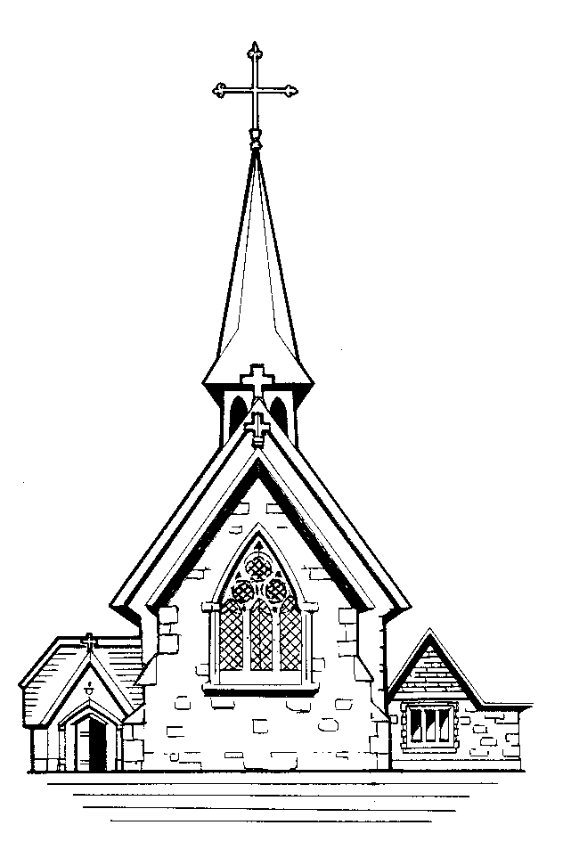 | Parish newsletter ST. EDWARD THE CONFESSOR  CATHOLIC CHURCH  (St Edward is the Patron Saint of our Deanery)  Parish Priest: Father Tom Jordan  5 Park End Road, Romford, Essex RM1 4AT  Telephone & Fax: 01708 740308  e-mail: romford@dioceseofbrentwood.org  Parish Website www.stedwards-romford.org.uk  Diocese of Brentwood Registered Charity No.234092  Web Site: www.dioceseofbrentwood.net  -----------------------------------------------------------------------  St. Peter’s Primary School 01708 745506  Head Teacher: Mrs Jenny Waterfield

Our Parish is part of the Brentwood Diocese and Alan Williams is our Bishop
and we belong to the Havering Deanery.
We are twinned with the parish of Regina Pacis, Ladysmith, Diocese of Dundee, South Africa,
and pray for their Bishop, Graham Rose

Tenth Sunday of the Year (B)

10th June 2018

Congratulations to our children who have received Communion for the First Time and who will celebrate their Communion breakfast this weekend:

Erin Bunce, Isabelle Bzheta, Michelle Chime, Natalie Church Benitez,
Caleb Eromomen, Jaeden Esau, Annabel Fulcher, Betty Gallagher, Louise Gordon, James Hayes, Sam Johnson, Oliver Jones, Maisie Lee, Shanice Mawoneke,
Kai McLaughlin, Cassandra Miners, Amelia Nichols, Fraser O’Sullivan,
Elliot Parham, Jovanny Peter, Antonina Piotrowska, Larry Raftery, Freya Rickard, Natasha Sloane, Jessica Tam, Zoe Ubaldo, Isabella Vanderleelie, Keira Waithe, Grace Weston, Mireille Williamson, Samuel Wilson and Francesca Baker.



